Exercise 1

Painting

This painting shows visual balance with the shape of the two fish. It is near symmetrical as it reflects over but they are not the same.

Graphic design

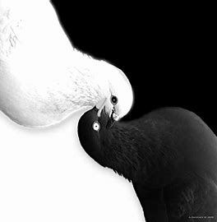This graphic design shows the visual balance using value. They have both sides of the value scale in the design.

Photograph

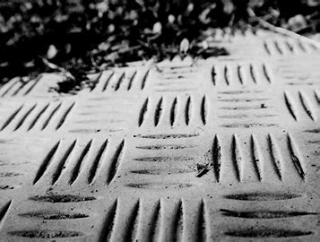 This photograph uses texture. There is a balance between the indents vertically and horizontally.

Illustration

This illustration has visual balance with color. There is even color saturation and the black background is even around the circle.

Exercise 2

Asymmetrical, There is a focal point in the middle and you can see the defined space but the blur in the back helps make that but the whole thing isn’t even.

Symmetrical, this is more near symmetrical. The tree in the middle divides the sides in half and they are basically the same on each side.

Unbalanced, the eye first goes to the Christmas tree with the red and green showing all of the weight goes to the right side.